Vendors Paid Via Standard Voucher Checklist
(Use instructions below for vendors that use their Social Security Number (SSN) and not an employer tax number (EIN).)
(Vendors using EIN’s, send vendor’s W-9 to Purchasing & Accounts Payable to be added to Red Dragon Depot (RDD) and do not proceed with this checklist as it will need to be entered via RDD.)

☐ Evidence of Terms of Agreement
- Must clearly state how much they will get paid for their goods/services (prior to supplying goods/services).
  - Email is acceptable

☐ Invoice
- Vendor must provide an invoice (department can provide a template, but department should not fill out the invoice themselves).
  - An acceptable invoice contains:
    - Invoice #
    - Invoice Date
    - Vendor Name & Address
    - To: SUNY Cortland, PO Box 2000, Cortland, NY 13045
    - Description of Goods/Services Requesting Payment for
    - Quantity of Goods or Date(s) of Service
    - Amount Requested
***If over $2,500, Reasonableness of Price Checklist is required per purchasing guidelines.***

☐ W-9
- Payee is required to submit their W-9, as this is a taxable service.

☐ Flyer
- If this was a campus event, include a copy of the flyer or email that went out to campus/group.

☐ Attendance Sheet
- If this was a campus event where attendance was taken, include a copy of the attendance sheet.

☐ Standard Voucher
- Areas to complete on Standard Voucher:

Top portion – Payee Information
- Payee Name (first & last)
- Email Address
- Address (Street, City, State Zip)
        - (where the check will be mailed to)

Middle Section – Description of Material/Service
- Date(s) and goods/services provided
- Total
- Net = Grand Total to be paid

Payee Certification
- Payee signs (no e-signature allowed)
- Date

Supervisor’s Certification
- Dept Chair/Director/Dean/VP signs (no e-signature allowed)
- Title
- Date

Cost Center Unit
- Add account # to charge
- Receipts & Backup
  - ☐ Scan voucher & backup and combine into (1) PDF with Standard Voucher.
    - ☐ Email fully signed Standard Voucher and backup to accounts.payable@cortland.edu.
Standard Voucher cannot be digitally or e-signed.

Signature Types:
NOT Allowed:
- Typed signature:
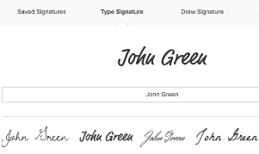
- Digital Signature:
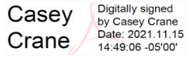
ALLOWED (original signature scanned):
- Original, scanned
